Q1:
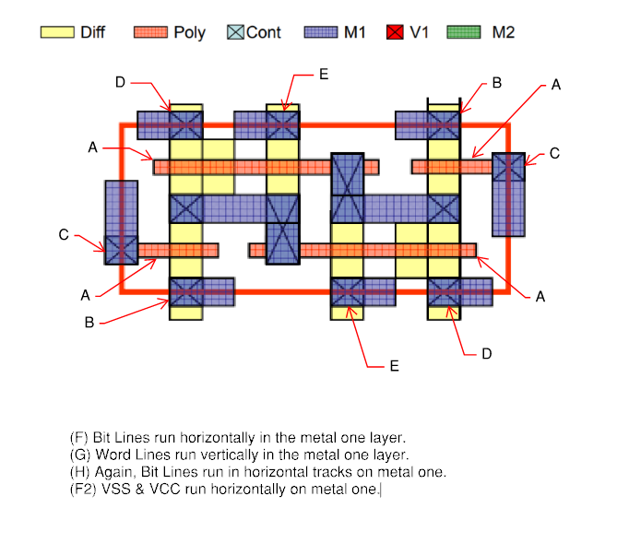

Q2:
2a) SRAM block capacity: 2¹² = 4096 (64-bit) words
4096 * 64 = 262,144 bits (256kb)

2b) Standard Bit Cell: Width = 0.2um, Height = 0.4 um
262,144 * 0.2um * 0.4um = 20971.52 um²
For a square we want array width = array height
So bits per row * width = rows * height

64x * 0.2 = 4096/x * 0.4 -> 12.8x = 1638.4/x -> 12.8x^2 = 1638.4 -> x ~= 11.3, so we choose 8 words a row since a mux requires a power of 2 for inputs and outputs.
4096 bits/8 words = 512 rows
Bits per row = 8 * 64 = 512 bits
Width = 512 * 0.2 = 102.4 um
Height = 512 * 0.4um = 204.8

Row decoder: log₂(512) = 9, so 9 inputs, 512 outputs
Column decoder: log₂(8) = 3, so 3 inputs, 8 outputs

2c) Total bits: 262,144
1nA leakage: 10⁻⁹ * 262,144 = 262.144 uA
At 1.1V: P_{leak} 262.144 uA * 1.1V = 288.4 uW

2d) 9 * 2^20 = 9 * 1,048,576 bytes = 75,497,472 bits
1nA * 1.1V = 1.1nW
1.1nW * 75,497,472 bits = 83.05mW
2e) T_{ox} = 1.5nm
f = 10⁻¹⁵
C_{ox} = E_{ox} / t_{ox} = (3.9 * 8.854 * 10⁻¹²) / (1.5 * 10⁻⁹) ~= 23fF/um²
C_{ox} * W * L = 0.46fF
2.0 fF/um * 0.2um = 0.4fF
C_{gate} = 0.46fF + 0.4fF = 0.86fF
C_{junction} = 0.5fF

C_{WL} = 64 * 2 * 0.86fF = 110.08fF
C_{BL} = 64*.5fF = 32fF * 2 = 64fF

C_{total} = 110+64 ~= 174fF
P_{cap} = CV² * f = 174 * 10⁻¹⁵ * (1.1)² * 2 * 10⁹ = 0.42108 mW
P_{total} = P_{leak} + P_{cap} = 0.42108 + 0.2884 = 0.70948 mW

Q3:
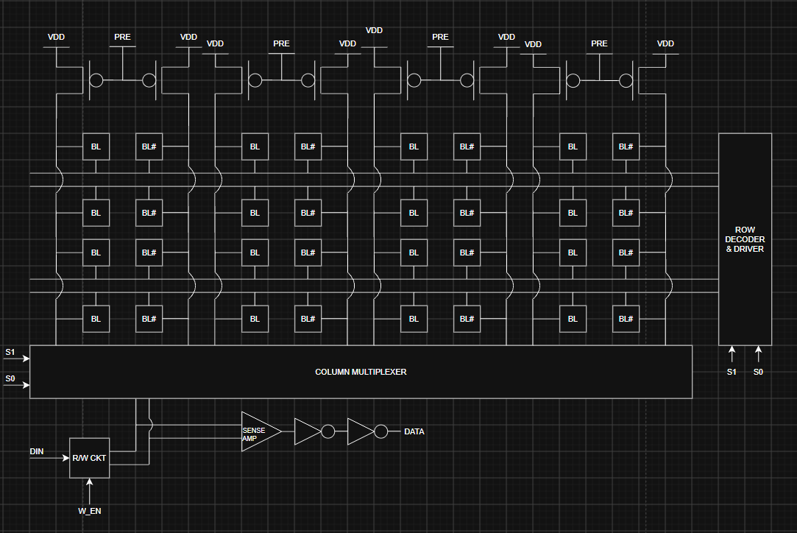
Q4: The gate is a NAND, with two NMOS in series, when both are true it pulls the output to ground upon a rising edge clock, otherwise outputting Vdd.

Q5: 8-1 Multiplexer Schematic (Left), Block (Right)
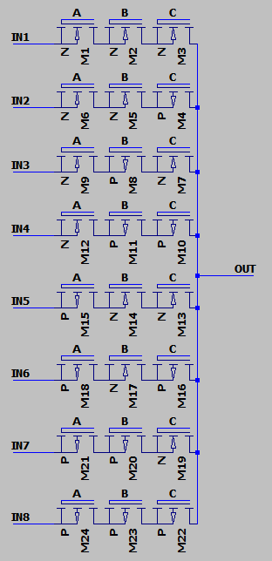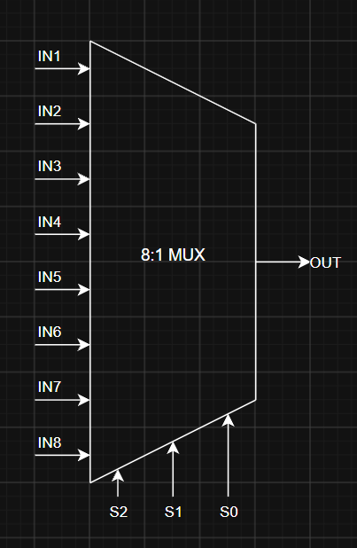

Q6: Used only NFET for the mux design, assumed we can use PFET for inverters per standard CMOS design.
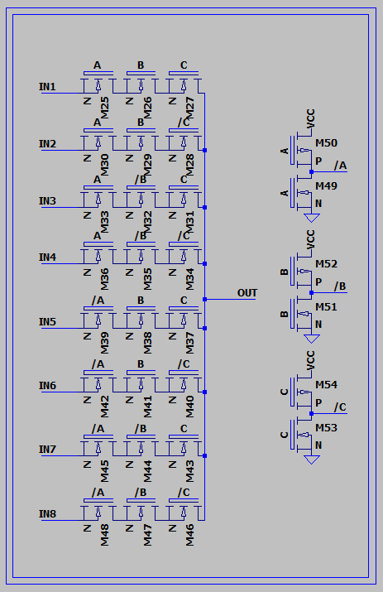
Lower noise margin. Since it does not pull as high (VDD – VT) there is less range for it to fluctuate before it could accidentally read as a 0 instead of 1.

Q7:
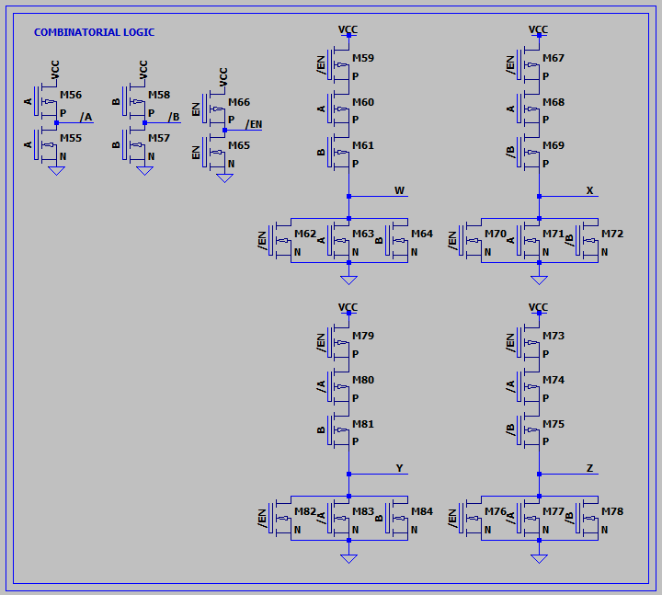

Q8:
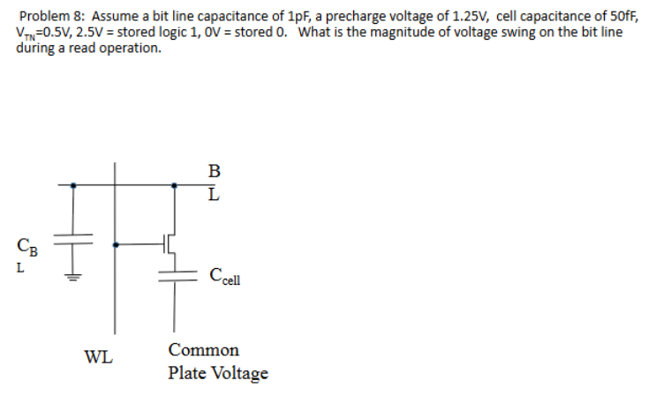
Swing $=\frac{C_{cell}\left(V_{cell}-V_{pre}\right)}{C_{BL}+C_{cell}}=50fF*\frac{2.5-1.25}{1000fF+50fF}=50*\frac{1.25}{1050}≅59.5mV$
Q9:
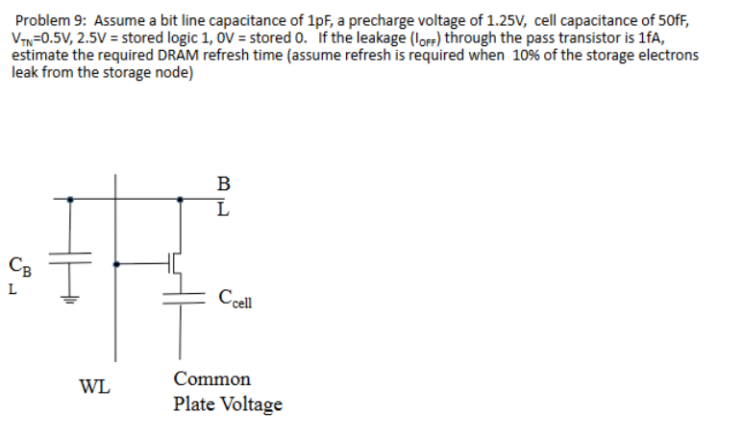
To find charge we do Q = CV, or $Q=C_{cell}V=50fF*2.5V=125fC$
.1Q = 12.5fC
T = Q/t = 12.5f/1fA = 12.5s refresh time.

Q10:
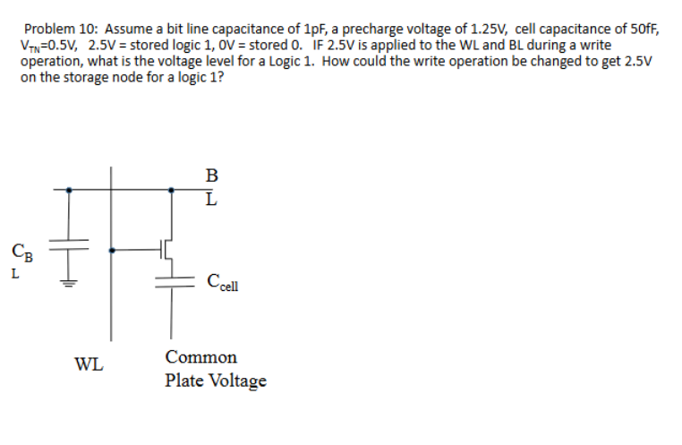
V_{cell} = V_{WL} – V_{TN} = 2.5 – 0.5 = 2.0, to get it to 2.5V on the output we would want to raise our V_{WL} to 3.0V, so that 3.0 – 0.5 = 2.5V.

